Dear Applicant

Thank you for your interest in the key role as Chair of the Diocesan Board of Finance (DBF) within the Diocese of Blackburn. Please find enclosed in your pack the following useful documents:

- Chair of DBF role description
- Chair of DBF person specification
- Diocese of Blackburn and its setting

Blackburn is one of 41 dioceses which cover the whole of England. With Vision 2026 creating Healthy Churches Transforming Communities, you would be joining us at an exciting time.

If you would like to have an informal discussion about this role, please do not hesitate to contact me via email at graeme.pollard@blackburn.anglican.org

A separate conversation with the outgoing Chair, John Dell can also be arranged by contacting me at the above email id.

I look forward to receiving your application which should consist of

- a CV or application form
- a covering statement/letter (no more than two sides of A4) detailing your reasons for applying and what you can bring to the post
- details of two referees, one of whom should be your current or most recent employer with the other being a representative from a parish/church
- An application form and other information can be found on the Diocesan website www.blackburn.anglican.org/general-vacancies

Closing date: Noon on Thursday 22 February
Please send application information to Jenny Simpkin, PA to the Diocesan Secretary & Head of Finance jenny.simpkin@blackburn.anglican.org
Selection/Interview date: Thursday 22 March

Yours faithfully

Graeme Pollard
Diocesan Secretary

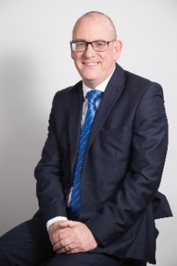

Contents

1. Job Description 2
1.1 Title 2
1.2 Context 2
1.3 Diocesan Finances 3
1.4 Key elements of the role 3
1.5 Specific Responsibilities 4
1.6 Key Working Relationships 4
1.7 Support 5
1.8 Time Commitment 5
1.9 Appointment process 5
2 Person Specification 6

Role Description

Title

Chair of the Diocesan Board of Finance

Context

The role of DBF Chair is a voluntary one, being an opportunity for a person to offer a significant Christian service to the life of the Diocese of Blackburn.
Every Diocese seems to have a DBF Chair who operates slightly differently. The following description is how the role currently operates in this Diocese. However, any person in such a role will bring different skills and will wish to develop the role in their own way.
The Chair is assisted by a Vice Chair. It is important to develop a close working relationship between these roles so that some of the following responsibilities can be shared between the two people.
The primary role of the DBF Chair is to Chair the Board of Finance Ltd (a charitable company limited by guarantee). The DBF Directors and Trustees delegate most of the financial detail to a Finance Committee, Investment Committee, Budget Committee and Governance, Risk and Audit Committee.
There can also be several working groups which the Chair may be invited to attend or Chair.
The DBF Chair also plays a key role in the strategic leadership of the Diocese including decisions about the direction and policies of the Diocese to deliver Vision 2026, the diocesan strategy for the next few years.
The Chair is an ex-officio member of the Bishop’s Council, ex-officio Chair of the Budget Committee and the Governance, Risk and Audit Committee and is an ex-officio Member of the Finance Committee. The DBF Chair is also a Bishop’s Nominee to the Diocesan Synod
Whilst the Bishop’s Council is chaired by the Bishop, it is the DBF Chair who chairs the part of the agenda relating to the meeting as Directors of the Board, including financial matters.
There is a strong representational element to this role in communicating with the wider diocesan family on the finances of the Diocese, explaining financial policy, including the budget and parish share and responding to questions.

Diocesan Finances

The main expenditure of the DBF is the cost of clergy (stipends, pensions, training, housing). The primary source of income derives from parishes using a system called Parish Share. Unlike a commercial company, the levers of control are difficult to invoke because of the nature and complexity of the Church of England in its structure/operation and a diocese’s collaborative relationship with parishes. This in turn requires a close linkage with the sources of income and how the money is spent.
Due to this close link between parishes and diocesan expenditure, the financial position of the Diocese is reasonably stable and has historically been well managed, but because the main source of income comes from parishes there are inevitable challenges.

Key elements of the role

To lead the DBF to:
- support, develop and agree priorities of the Diocese, relating to financial matters, ensuring through a budget that they can be funded (and alerting the other directors when the funding requirement is too great to ensure that the Diocese is not over-committed).
- ensure that it fulfils its responsibilities as per its Memorandum and Articles of Association.
- inspire confidence in sound financial management of the Diocese, through financial planning, monitoring key performance indicators, control processes, governance and transparent open reporting and to encourage finance to be an instrument for mission.

Specific Responsibilities
- to chair meetings of the Board of Directors and Budget Committee.
- as lead Finance Trustee, in conjunction with the Diocesan Secretary and the Head of Finance, to support, encourage and oversee the financial control of the Company; to ensure appropriate reporting including accounting, financial and asset management, budgeting and forward planning, legal matters; to ensure that the organisation complies with both Company and charity law and other relevant legislation and regulations.
- to engage with the parishes and deaneries and communicate with the wider diocesan family on matters of finance.
- to be one of the representatives of the Diocese at the Inter-Diocesan Finance Forum which meets twice per year in London.
- to review and support the Diocesan Secretary, through regular meetings, in their role of oversight for all those employed by the DBF.

Key Working Relationships
- the Bishop of Blackburn and the Bishop’s Leadership Team
The Chair needs a working relationship with The Bishop and senior staff, in which issues of concern (whether financial, local, national or otherwise) may be raised with confidence that they will be acknowledged and accorded due prioritisation.
the relationship with the two Archdeacons is particularly important as they work closely with parishes.
- the Vice Chair – who also chairs the Finance Committee and Investment Committee.
Sharing responsibilities and ensuring a common approach and common key messages on Finance are given.
- the Diocesan Secretary.
- the Head of Finance (Deputy Diocesan Secretary) and Vision Coordinator (Deputy Diocesan Secretary).
- members of the Bishop’s Council, the Finance Committee, chair of the Property Committee, the Dean of the Cathedral and other committees/working groups.

Support

The office of Chair is not remunerated, but the Chair is encouraged to reclaim all necessary expenses of office.

The Diocesan Secretary and the Finance Team will provide administrative support for this role. There can be some communication - e-mails, phone calls, letters - and the diocesan office is willing to support the Chair in handling these. The Finance Team and Property Team will also provide support on financial and property information.

The Chair will, if they wish, have access to the Diocesan Contact Management System, access to the Directors’ secure are in SharePoint and will have a diocesan email address.

Time Commitment

- the Bishop’s Council currently meets five times a year, generally on Saturday mornings.
- Diocesan Synod currently meets three times a year on a Saturday morning, although this may change to two Saturdays and one midweek evening.
- Finance Committee meets six times a year, usually on a Tuesday from 3.30pm until 6.00pm.
- regular contact with the Diocesan Secretary and the Head of Finance, to be mutually agreed.
- occasional meetings with the Bishop and others.
- attend if possible the Inter-Diocesan Finance Forum held in London twice a year.

The Chair will need the time and capacity to fulfil the role, though to a large extent the role can be adapted to suit the individual and their circumstances.

Appointment process

The Chair is recommended to the Diocesan Synod by the Bishop of Blackburn and, when ratified by the Synod, serves for a period of three years or up to the next triennium (the three-yearly election cycle) if appointed outside the election cycle.

There is no limit on the length of time for holding the role.

Person Specification

 | Essential | Desirable
Experience | - have a professional background in business or finance or other appropriate context, can demonstrate sound business, financial, operational problem solving skills and ideally have an understanding of charitable governance
Knowledge | - have knowledge, sympathy and understanding of the work of parishes
Skills | - an effective chair of meetings  - good communication skills  - ability to think strategically about both finance and mission  - ability and willingness to appropriately challenge as well as support others  - act fairly and impartially in the interests of the Diocese and the DBF, using independent judgement and confidentiality as appropriate  - can lead, inspire and foster a collegiate manner of working with both staff clergy and volunteers
Behaviours | - have a committed and mature Christian faith

The Diocese of Blackburn and its Setting

Location
The Diocese of Blackburn is in the north-west of England, bounded by Morecambe Bay to the west and surrounded by Carlisle, Manchester, Liverpool and Leeds dioceses. There are coastal plains to the west and the foothills of the Pennines to the east. See the map overleaf.
There are several large centres of population, with attractive countryside between them, with many small towns and villages.
The boundary of the diocese is virtually coterminous with the geographic county of Lancashire; that is the administrative county plus the Unitary Districts of Blackburn with Darwen and Blackpool.
There are some slight variations:

- To the south west a large part of West Lancashire District is excluded (Diocese of Liverpool)
- To the south and south east of the Diocese, an area of Greater Manchester – Borough of Wigan – is included in the Diocese and parts of the Borough of Rossendale are excluded (Diocese of Manchester)
- To the north east, small parts of both the Ribble Valley and Pendle Borough are excluded (although parishes have recently been welcomed into our Diocese as part of changes to the dioceses in Yorkshire)

Structure
The diocese is the principal pastoral and, in turn, financial and administrative resource of the Church of England under the spiritual leadership of the Diocesan Bishop.
The Diocese of Blackburn has two archdeaconries, each under the responsibility of an archdeacon. The Lancaster Archdeaconry covers the area north of the River Ribble and the Blackburn Archdeaconry covers the area south of the Ribble.
Each archdeaconry has seven deaneries, which is a number of benefices/parishes grouped geographically with an area dean having oversight.
A benefice is a parish or group of parishes served by an incumbent who typically receives a stipend and the benefit of occupation and use of a parsonage house provided by the diocese for carrying out spiritual duties.

Structure governance and management
The Diocese of Blackburn was created in 1926. It has an area of 878 square miles and encompasses most of Lancashire with a few parishes in Wigan Metropolitan Borough. The overall population is 1.29 million within urban and rural areas.

The Cathedral

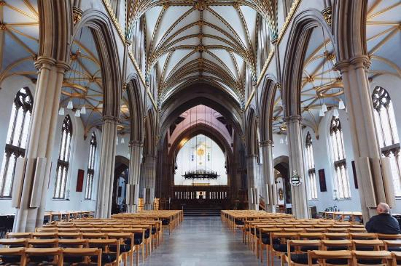
Blackburn Cathedral is one of England's newest Cathedrals, yet it is one of the country's oldest places of Christian worship.

For many centuries, there has been a church on the site of the current cathedral. The Parish Church of Blackburn dedicated to St. Mary the Virgin became the Anglican Cathedral for the Diocese of Blackburn (The Church of England in Lancashire) in 1926.
The cathedral continues as a place of prayer and worship (especially as a centre of choral excellence), and shares in the Diocesan Vision 2026: Healthy Churches Transforming Communities. The Dean is an active member of the Bishop's Leadership Team and Bishop's Council and Board of Finance Directors.

Whalley Abbey

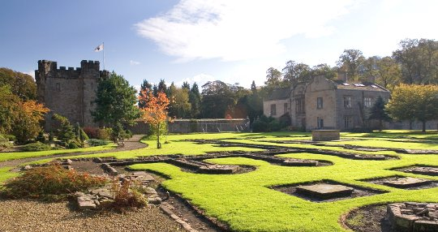
The Retreat and Conference House is set in the stunning grounds and ruins of a 14th Century Cistercian Abbey. On the banks of the River Calder in the beautiful countryside of the Ribble Valley, and with easy access to motorway and rail network.
The Abbey has a programme of residential retreats, spirituality days and quiet days for clergy which provide a variety of occasions to be still and quiet, to hear from God through His Word and be refreshed in Love for Jesus Christ.
Each Diocese of Blackburn parish can book a room at the Conference Centre for a retreat or other parish get-together completely free of charge once a year.
The grounds and ruins are open to visitors to explore (small charge) with Cafe Autisan (run by a separate charity) open for refreshments from 10am-4pm seven days a week.

F. Finance

The diocese has an annual expenditure of approx. £11.5 million and aims to achieve a breakeven position or strategic use of reserves each year.

G. International links

Links with Lutheran Church in Braunschweig and the Diocese of the Free state in South Africa.

